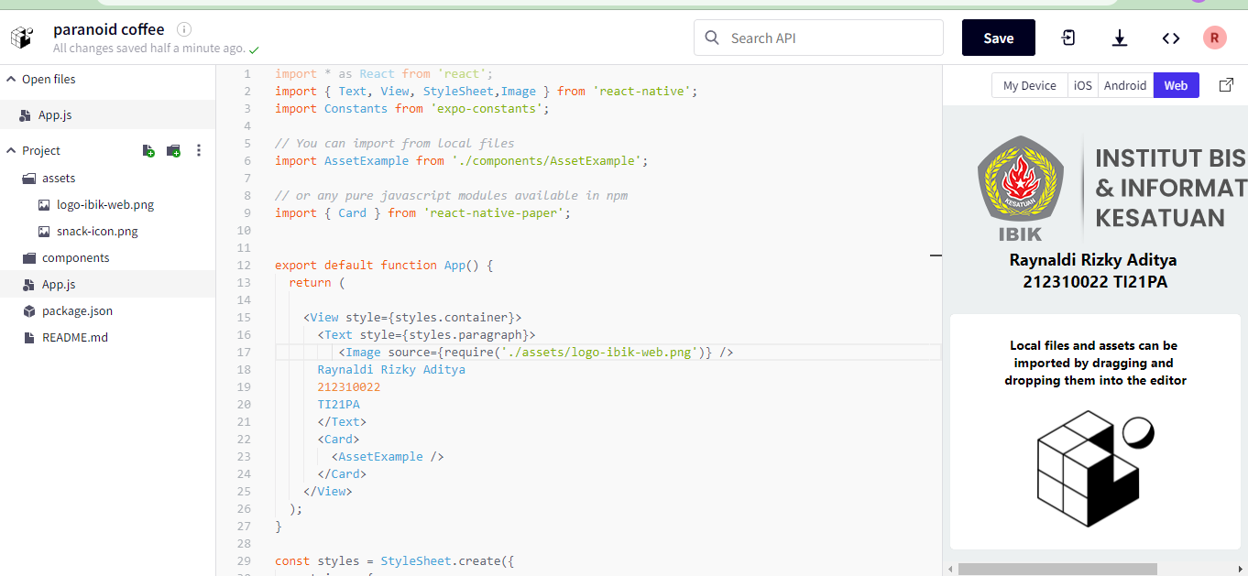

import \* as React from 'react';

import { Text, View, StyleSheet,Image } from 'react-native';

import Constants from 'expo-constants';

*// You can import from local files*

import AssetExample from './components/AssetExample';

*// or any pure javascript modules available in npm*

import { Card } from 'react-native-paper';

export default function App() {

  return (

    <View style={styles.container}>

      <Text style={styles.paragraph}>

         <Image source={require('./assets/logo-ibik-web.png')} />

      Raynaldi Rizky Aditya

      212310022

      TI21PA

      </Text>

      <Card>

        <AssetExample />

      </Card>

    </View>

  );

}

const styles = StyleSheet.create({

  container: {

    flex: 1,

    justifyContent: 'center',

    paddingTop: Constants.statusBarHeight,

    backgroundColor: '#ecf0f1',

    padding: 8,

  },

  paragraph: {

    margin: 24,

    fontSize: 18,

    fontWeight: 'bold',

    textAlign: 'center',

  },

});